**KOREA IT SCHOOL**



**FINAL PROJECT REPORT**

PROJECT NAME: MOVIE WEBSITE

TEAM 4:

Ho Si Dat

Tran Khanh Quang Bao

Nguyen Dang Khoa

Vu Van Minh

**HO CHI MINH CITY, 2023**

**THANK YOU MESSAGE**

We are very grateful for every one in KITS. Four mentors, our friends and another people who help us in three months. In the past Three months, we learn many knowledge from mentors and thank for that knowledge we can complete our project. And when we have problem in final project, all mentor have us very much.We also thank to employee in kits who bring us chance to be an intern in IT company.

In project progress, we use all knowledge we have in and out of KITS course, but because of lack experience and knowledge, we can not do it perfectly. So we expected you to give feedback to us so that we can improve it in the future.

Finally, we wish all of you have a good health and successful in your career.

1. **About the project:**
   1. **Reason to choose project:**

In the daily life, everyone is facing to stress from work, and relationship. When having stress, you want to have way to relieve stress. Therefore, we make this website where everyone can watch film.

* 1. **Overview:**

A film website where everyone can search and watch film.

* 1. **Target:**

Apply knowledge into the real world to make full website with as much as possible feature.

1. **Encounter problem and solution:**

While using git, we usually have merge conflict to merge code together. To resolve it, we check all conflict files and choose suitable code line and paste it to one file.

Because of experience lacking, we have many bugs when code. Fix it is too difficult. We use some common ways to fix it, such as search with google, chat GPT or ask mentor.

Sometime, deadline comes near but task is not completed, we have a meeting to know each other problem and propose solution or help it order to finish tasks as soon as possible

1. **Knowledge used for project:**

Frontend:

* React: (also known as React.js or ReactJS) is a free and open-source front-end JavaScript library for building user interfaces based on components. It is maintained by Meta (formerly Facebook) and a community of individual developers and companies.

React can be used to develop single-page, mobile, or server-rendered applications with frameworks like Next.js. Because React is only concerned with the user interface and rendering components to the DOM, React applications often rely on libraries for routing and other client-side functionality.

* HTML:HTML stands for HyperText Markup Language. It is a standard markup language for web page creation. It allows the creation and structure of sections, paragraphs, and links using HTML elements (the building blocks of a web page) such as tags and attributes.
* CSS: CSS is the language we use to style an HTML document. CSS describes how HTML elements should be displayed.
* AntDesign: Ant Design is a React. js UI library that contains easy-to-use components that are useful for building interactive user interfaces. It is very easy to use as well as integrate. It is one of the smart options to design web applications using react. It provides us with high-quality components which can be used with ease.
* Redux(Rematch):Redux is an open-source JavaScript library used to manage application state. React uses Redux for building the user interface. It was first introduced by Dan Abramov and Andrew Clark in 2015.

React Redux is the official React binding for Redux. It allows React components to read data from a Redux Store, and dispatch Actions to the Store to update data. Redux helps apps to scale by providing a sensible way to manage state through a unidirectional data flow model. React Redux is conceptually simple. It subscribes to the Redux store, checks to see if the data which your component wants have changed, and re-renders your component.

Backend:

* Java:Java is a programming language and computing platform first released by Sun Microsystems in 1995. It has evolved from humble beginnings to power a large share of today’s digital world, by providing the reliable platform upon which many services and applications are built. New, innovative products and digital services designed for the future continue to rely on Java, as well.
* Spring boot: Java Spring Framework (Spring Framework) is a popular, open source, enterprise-level framework for creating standalone, production-grade applications that run on the Java Virtual Machine (JVM).

Java Spring Boot (Spring Boot) is a tool that makes developing web application and microservices with Spring Framework faster and easier

* MySQL: In regard to the general definition, MySQL is an open source relational **database management system** (RDBMS) with a client-server model. **RDBMS** is a software or service used to create and manage databases based on a relational model.
* Docker: Docker is an open platform for developing, shipping, and running applications. Docker enables you to separate your applications from your infrastructure so you can deliver software quickly. With Docker, you can manage your infrastructure in the same ways you manage your applications. By taking advantage of Docker’s methodologies for shipping, testing, and deploying code quickly, you can significantly reduce the delay between writing code and running it in production.
* Maven: Maven is a popular open-source build tool developed by the Apache Group to build, publish, and deploy several projects at once for better [project management](https://www.simplilearn.com/project-management-skills-article). The tool allows developers to build and document the lifecycle framework. Maven is written in [Java](https://www.simplilearn.com/tutorials/java-tutorial) and is used to build projects written in [C#](https://www.simplilearn.com/c-sharp-programming-for-beginners-article), Scala, [Ruby,](https://www.simplilearn.com/tutorials/java-tutorial/what-is-ruby-on-rails) etc. Based on the Project Object Model (POM), this tool has made the lives of [Java developers](https://www.simplilearn.com/introducing-simplilearns-full-stack-java-developer-masters-program-article) easier while developing reports, checks build and testing automation setups.

Other:

* Git: Git is a [free and open source](https://git-scm.com/about/free-and-open-source) distributed version control system designed to handle everything from small to very large projects with speed and efficiency.

1. **Main project feature:**
   1. **Show film:**

Show all film in database with name, genres, images when click on image, it will redirect to watch film page.

* 1. **Search film:**

User can search film by name

* 1. **Filter genres:**

User can choose film that match with genre you want to watch.

* 1. **Comment:**

User can write a feedback to website about the film, or something you are not satisfied about the web such as loading speed, so many advertisement or the title and the episode is not matched

* 1. **Buy film:**

Film with tag fee is film that you must buy before you watch it. To buy it, you must login first. When you click buy, you will be connected to Paypal wallet and buy it.

* 1. **Admin page:**

This page is where to manage information about user, film, comment and package.

1. **System Design:**

The CMM MOVIES system is designed with a Database with the following tables:

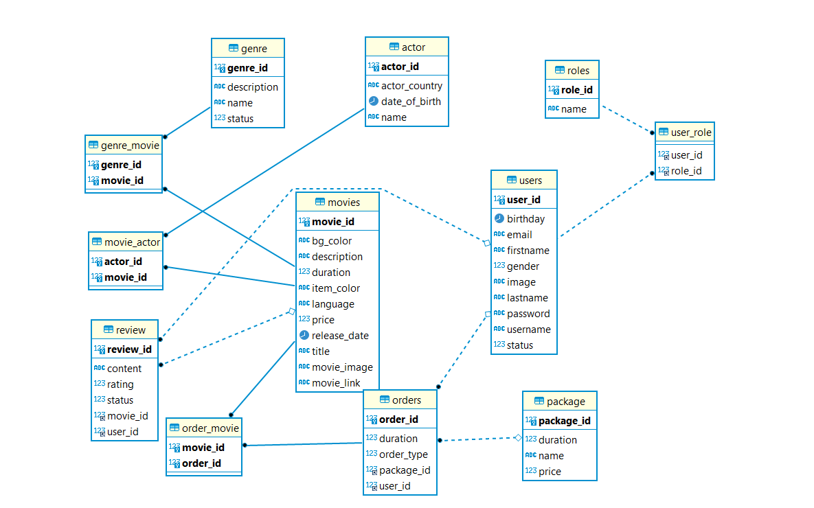

1. **User interface design**
2. Home Screen: Have navigation bar on the top of page. below the navigation bar, this is a slider with many film

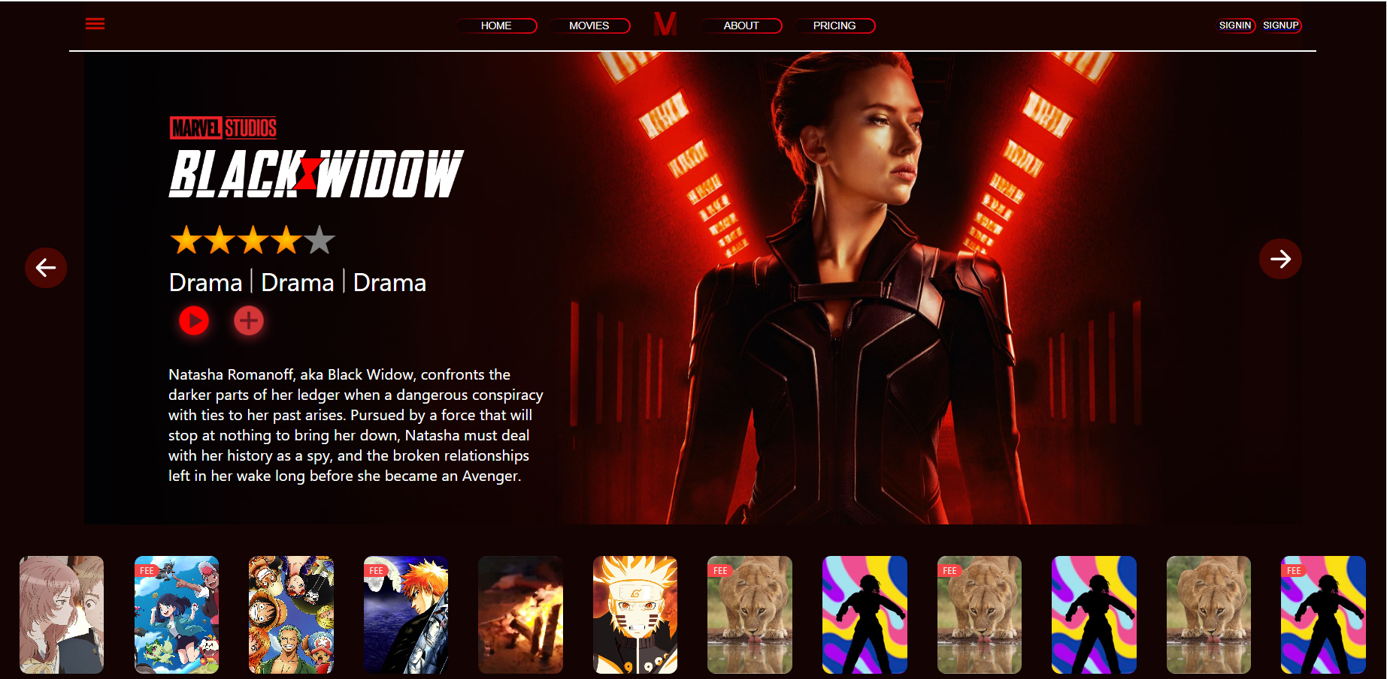

*Function: we can slide to left or right to see more.*

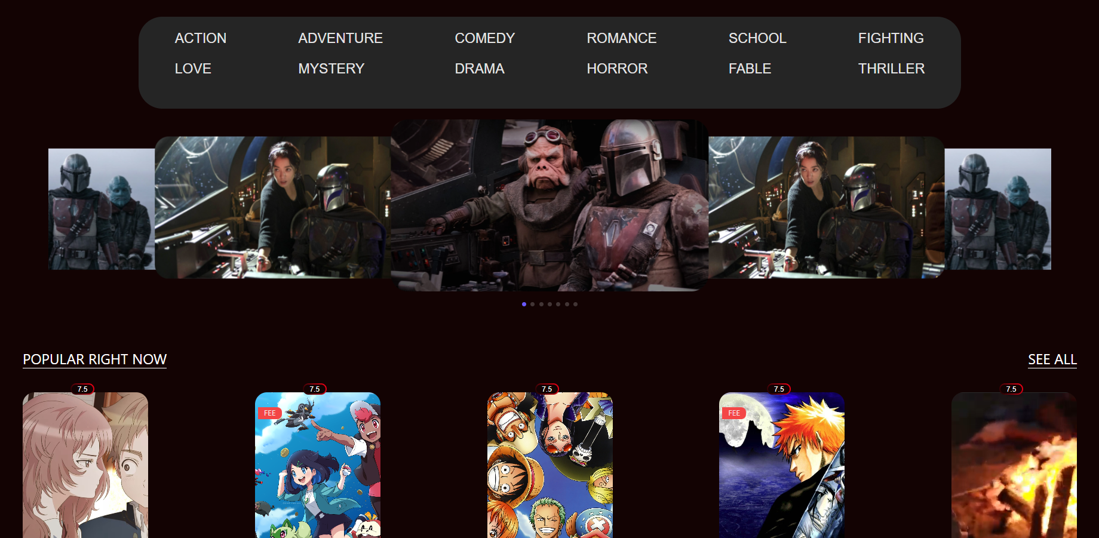

*Function: We can choose film with have matched genre and we can search film with name*

b)Details Movie:

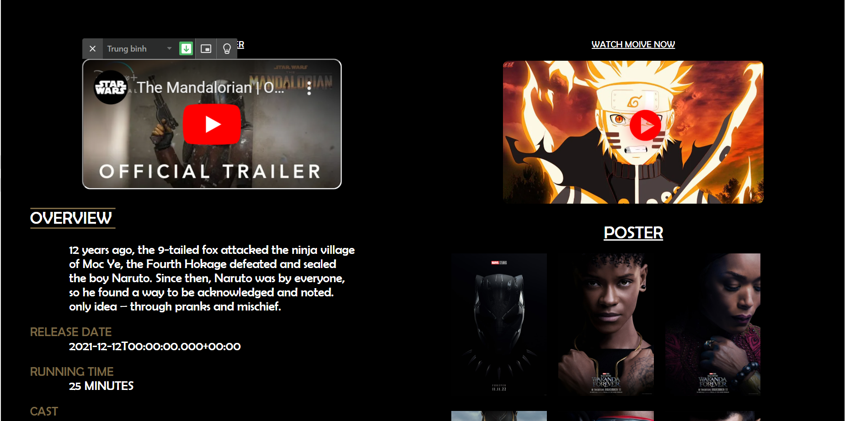

*Function: This page show after you click at one film on the home page. It contains all information about film, such as overview, release date, duration …*

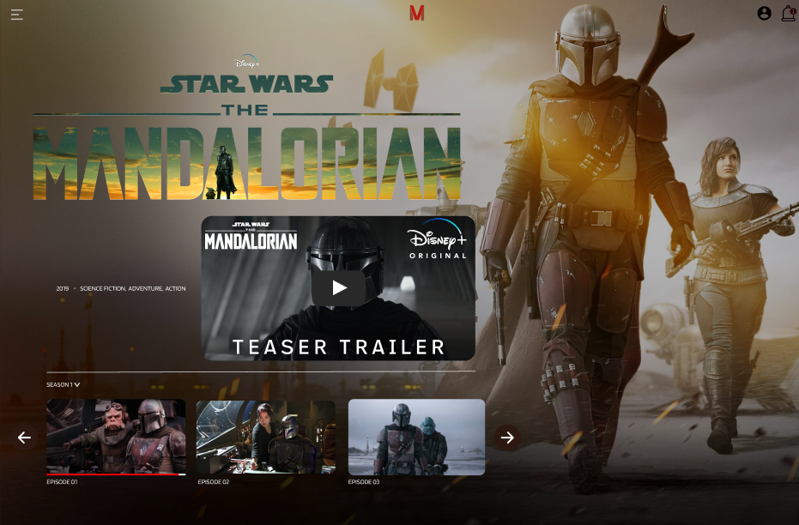

After click watch film now at before page, it will be redirect to this page at you can watch film.

c)About Us

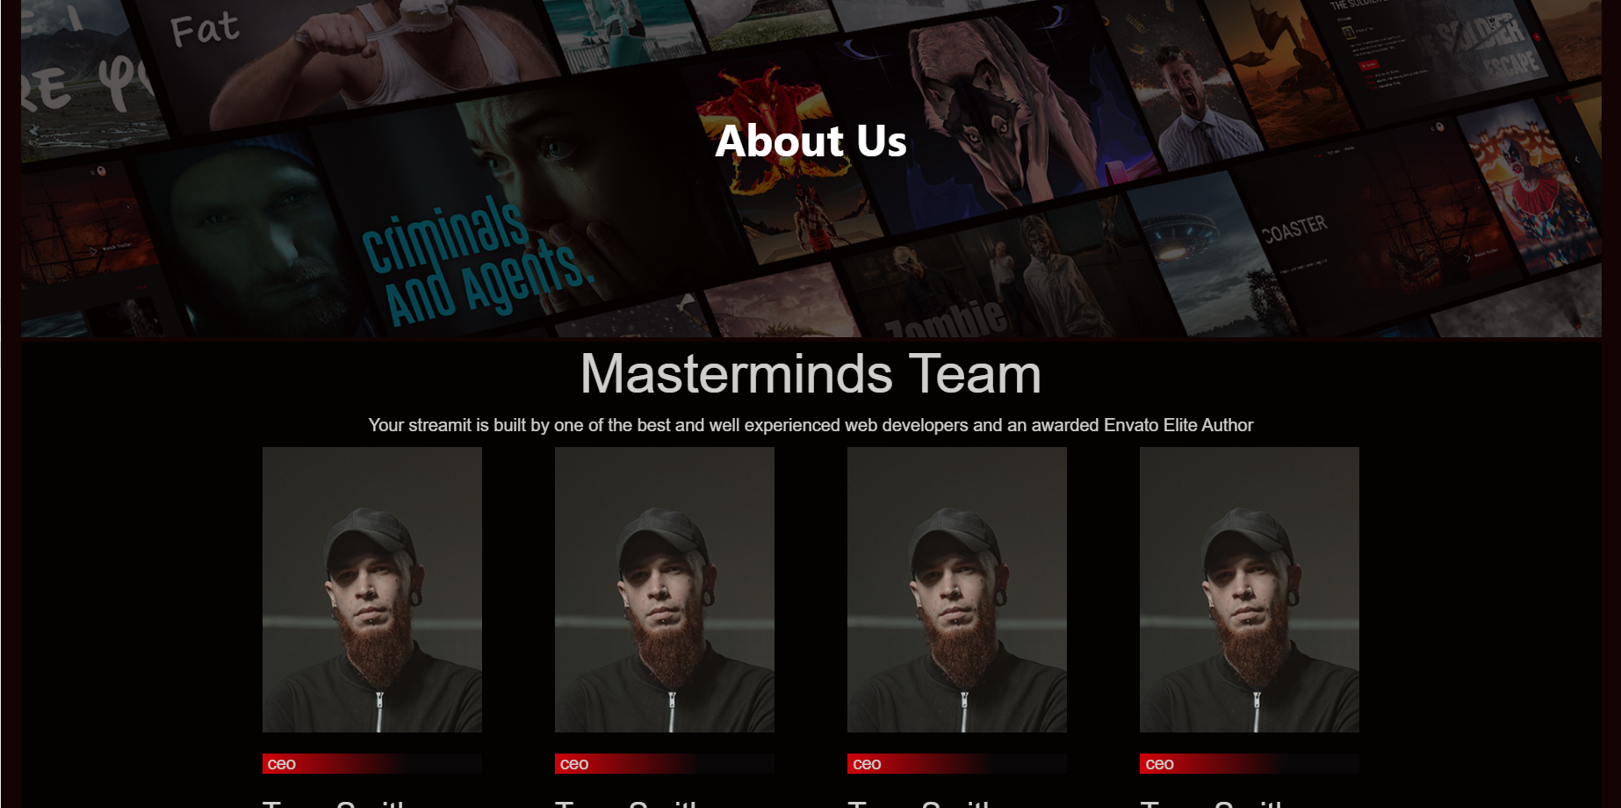

*This page show information about owner team*

d)Pricing:

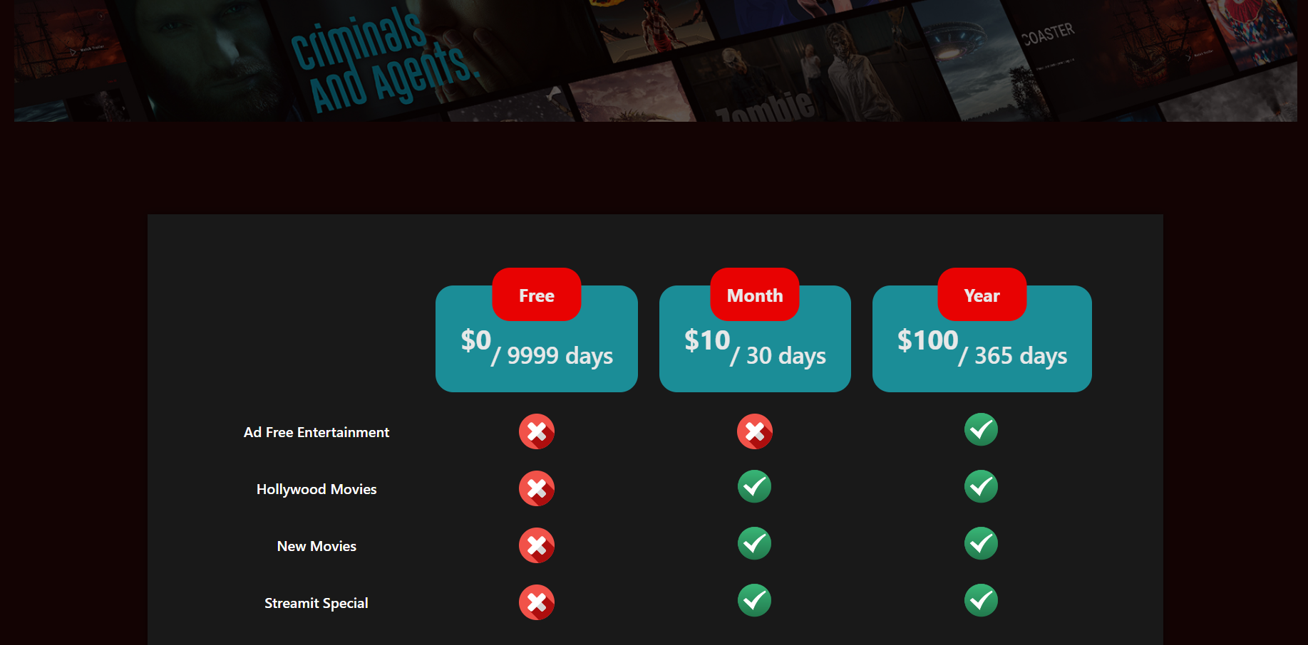

This page contains package information

e)Payment

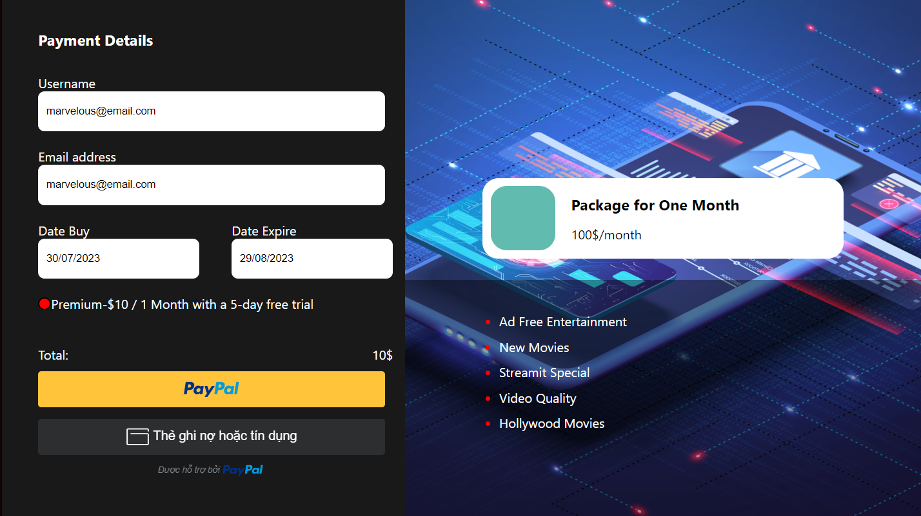

When click buy on pricing page, it will redirect to payment page, at here you will fill in all of your information and purchase package

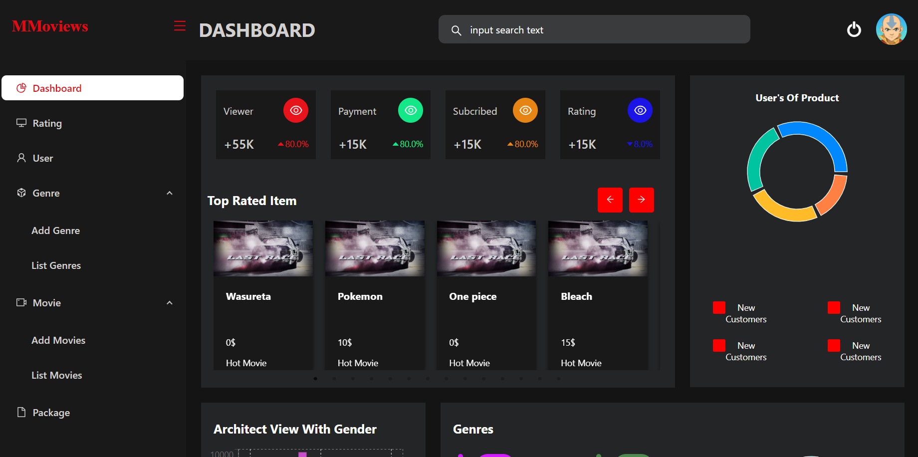

This page is admin page, where manage all information about web, from user to genre, from movie to package and more

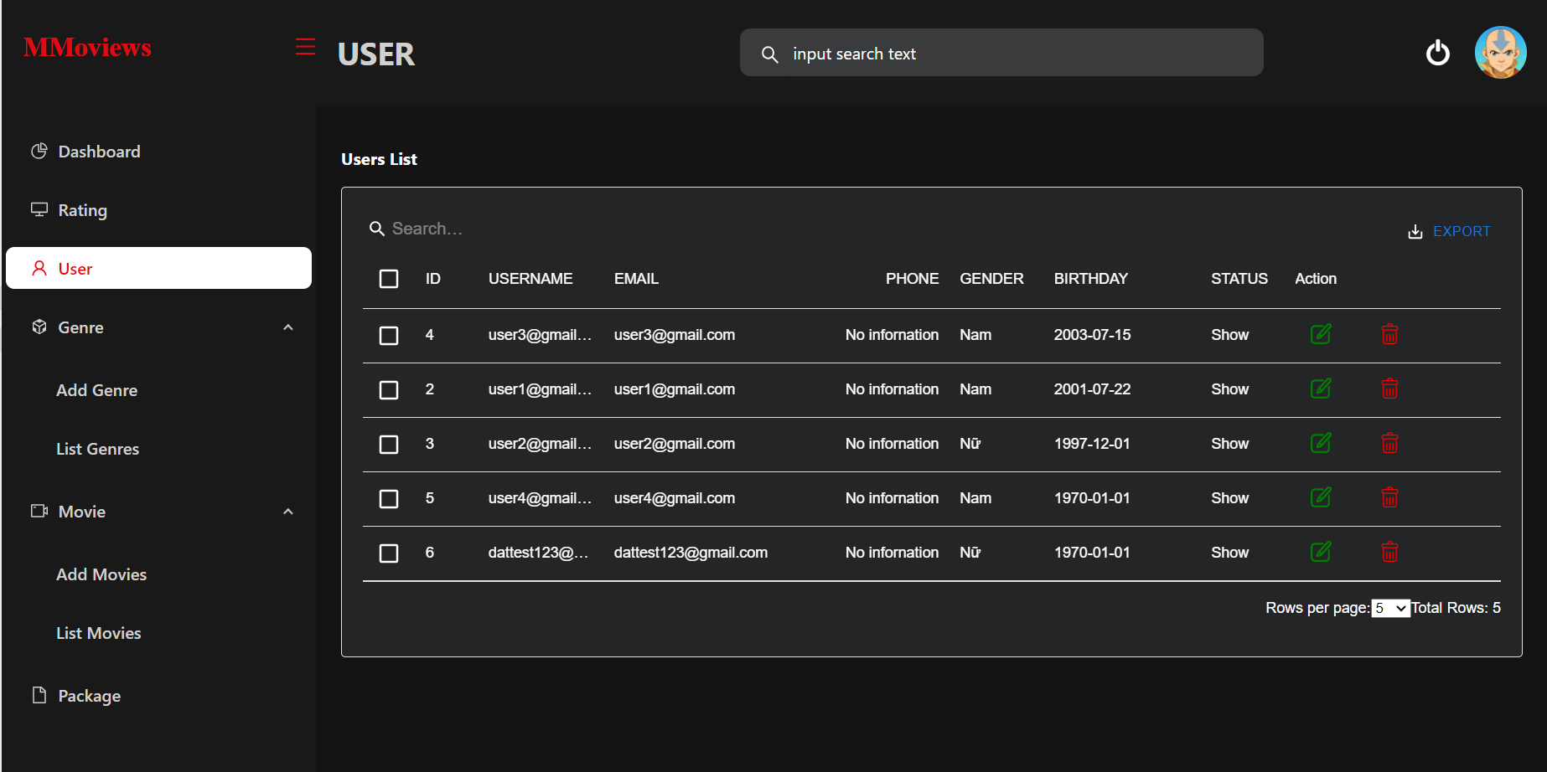

We can change and manage user detail on user tab.

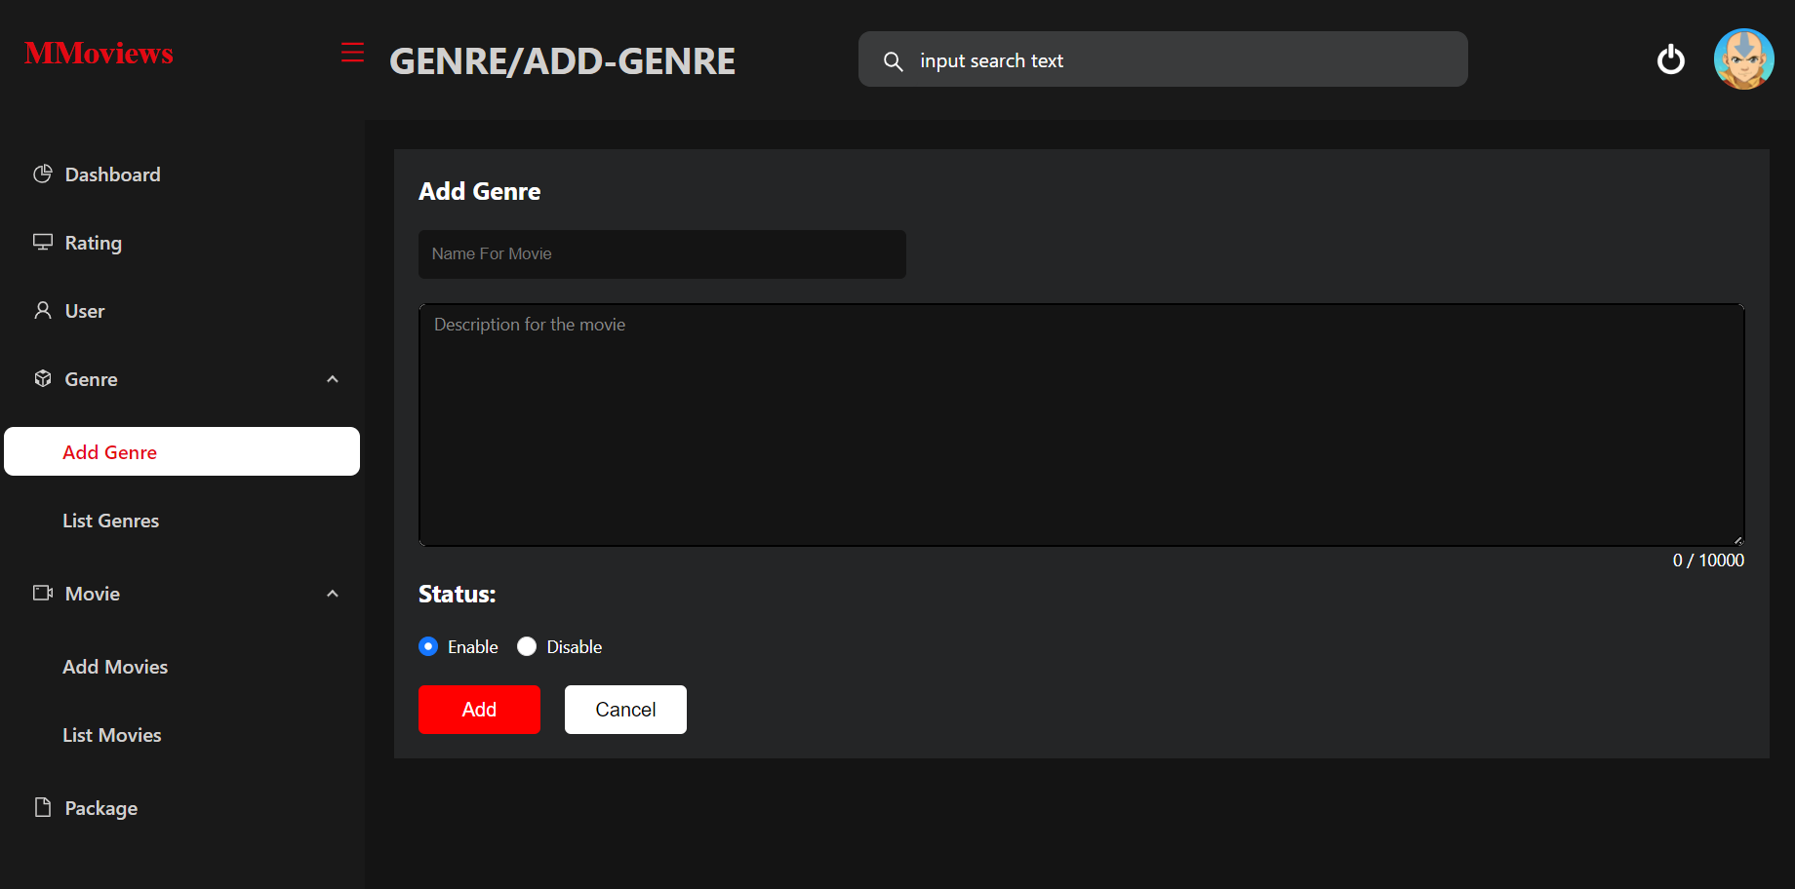

We can change and manage genre detail on genre tab.

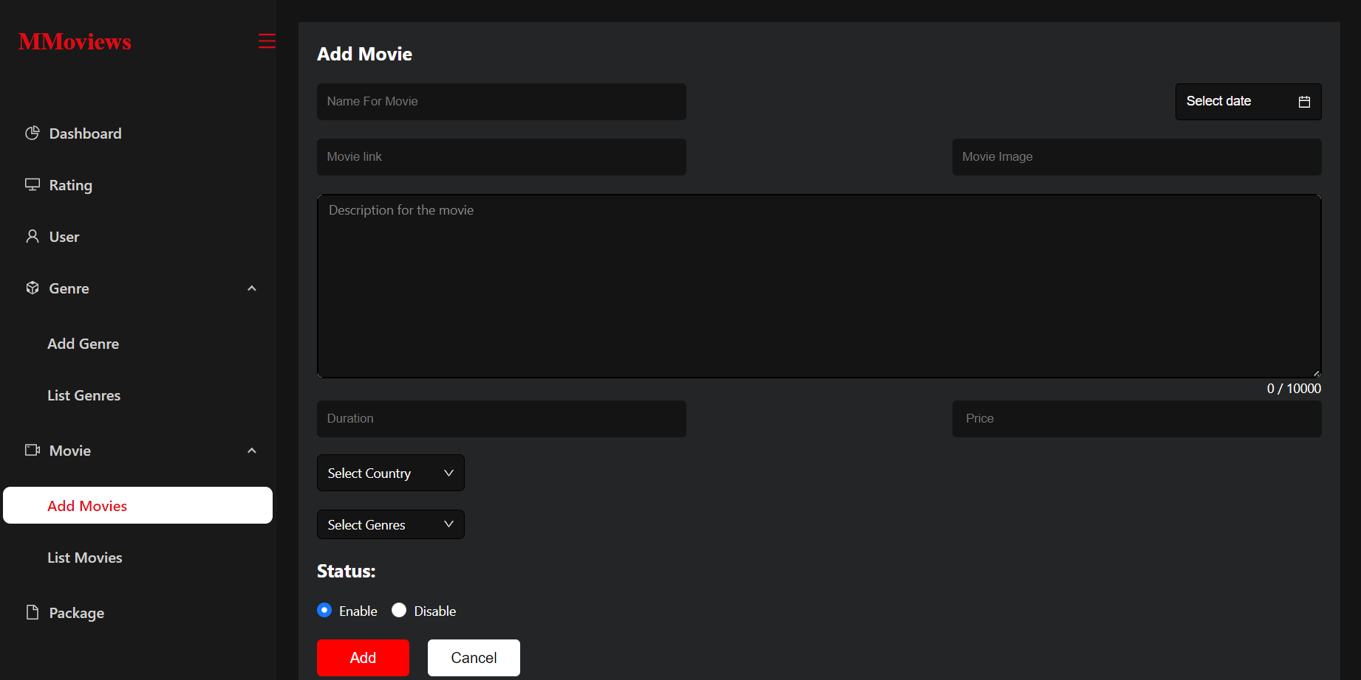

We can change and manage movie detail on movie tab.

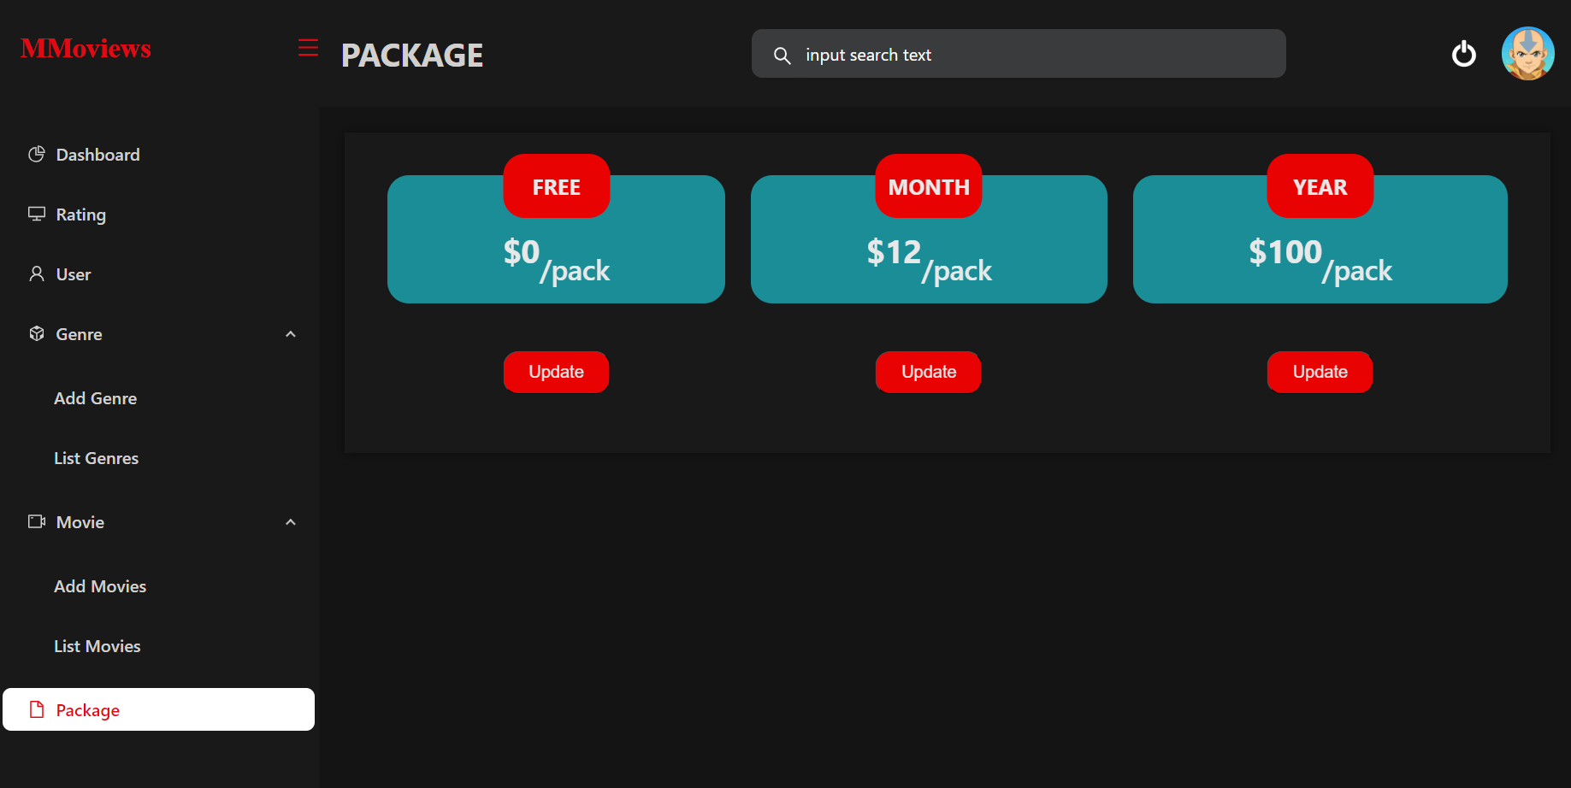

We can change and manage package detail on package tab.

1. **Summary**

**page:** [**https://adminpage-opal.vercel.app/**](https://adminpage-opal.vercel.app/) **admin:**[**https://cmm-movies.vercel.app/**](https://cmm-movies.vercel.app/)

Github Team 4: [bao2k1/KITS-FinalProject-Team4 (github.com)](https://github.com/bao2k1/KITS-FinalProject-Team4)

Help the students apply their knowledge into the real world:

* FRONTEND: ReactJS, HTML, CSS, Ant Design, Redux(Rematch)
* BACKEND: Java, Spring boot, MySQL, Docker, Maven

SKILLS:

* TEAMWORK
* HOW TO USE GIT
* DATABASE MANAGEMENT
* UNDERSTANDING A REAL-WORLD PROJECT

GOALS

* Develop a simple Movies Web: CMM Movies Web App.
* Complete this final project to finish the course